**WEEK – 8 ARRAYS OBJECTS AND MORE**

**WEEK-8 MASTERING JS – ARRAYS, OBJECTS, MORE**

**WEEK-8 MASTERING JS – ARRAYS, OBJECTS, MORE**

**MODULE – 1 WORKING WITH ARRAYS**

**TOPIC: 1 THE ARRAY PROTOTYPE:**

Prototype: methods & properties available for the object that is created

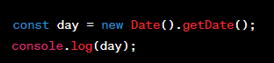

* Date is an object in JS, represents the current date and time
* getDate method is called. This method returns the day of the month and date stored in date object
* const day = day is the variable name
* const = keyword to declare variable. Value cannot be changed after its assigned
* let,var = keyword to declare variable. Value can be changed after its assigned

**TOPIC: 2 REVERSING AN ARRAY**

* It is a Mutator method
* It reverses the elements in an array but order of indexing wont be affected
* Reverse() = reverse method
* toString() = method is used to convert any data type into string

Eg: sensorData

* inside array we created objects
* we used for loop
* date,maxTemp,minTemp elements we are accessing from objects
* for loop lo reverse() method use chesam
* paina data kindaki , kinda data paiki vasthundi

Eg: palindrome

* isPalindrome = function name
* word = argument of function isPalindrome
* This function will check if the given word is a Palindrome
* 2 empty arrays were initialized. These arrays will be used to store characters from the input word and its reverse, respectively.
* for...of loop, which iterates over each character in the word string
* Adds original word
* Reverse the original word
* compares the stringified version of wordArr and the stringified version of revWord.reverse(). It checks if the original word and its reverse are the same. If they are, it means the word is a palindrome, and true is returned; otherwise, it returns false.
* calls the isPalindrome function with the input word "hello." Depending on whether the word is a palindrome or not, it prints "Is a palindrome!" or "Not a palindrome..." to the console.

Eg: weapons

* array wepons contain several objects
* function = display weapons
* parameter = arr
* for of loop
* const elem of arr = iterates over each element in an array
* iterates over each item and its cost
* function called with array name
* reverse method is used here

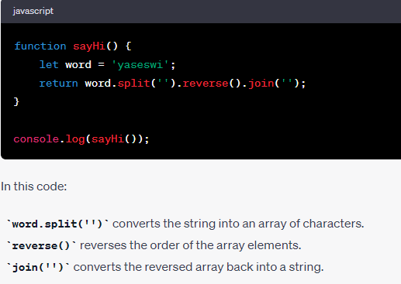

**TOPIC: 3 CONVERTING STRINGS TO ARRAYS AND BACK**

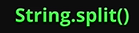

* converts strings to arrays



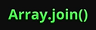

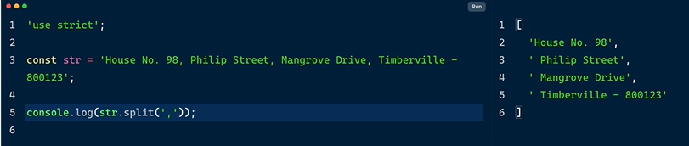

String.split() method used comma as a separated

String is converted to array

With no comma output will appear like each character separated by a comma like below including symbols, spaces

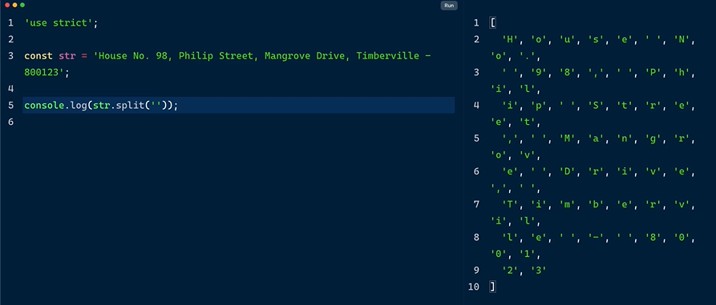

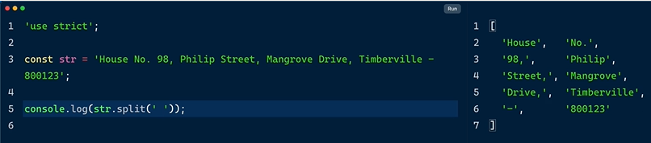

* breaked with a white space

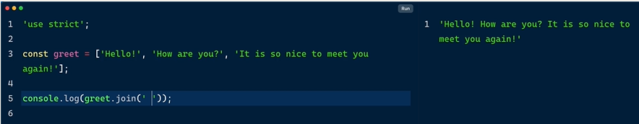

* Array of multiple string elements
* Join method is used to convert array into string
* Join separated by white space above
* Check with coma and space
* Check with vestibule ::::

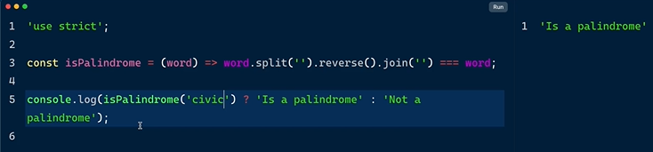

* isPalindrome = function
* word argument
* added split,reverse,join to argument
* strict equality operator used to check input word with argument

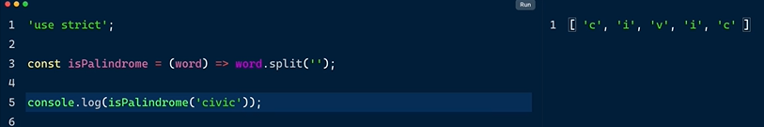

* split method is used first to separate the word’s each character
* next added the reverse method which reverse the word in the output console
* use word hello instead of civic
* now join this array using empty string , we get a reversed word
* use strict equality with the original word
* implemented ternary operator con? T:F

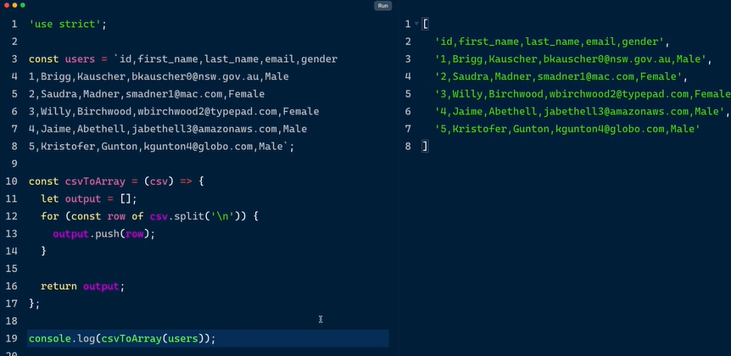

* Here is a string comma separated data from a CSV file
* Convert data into array for readability
* csvToArray = function name
* this function accepts a string of coma separated by values
* instanciated output named array
* for of loop to iterate
* splitting it with newline escape character
* return output
* and execute the function by passing string



* 13th line splits each row by using split method wit comma as speartaed to get nested arrays



* Instead of using console.log use console.table for tabular arrangement of data

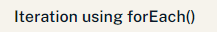

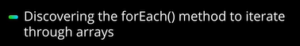

For of loop to iterate to array

For each method is also used to loop an array which is very easy

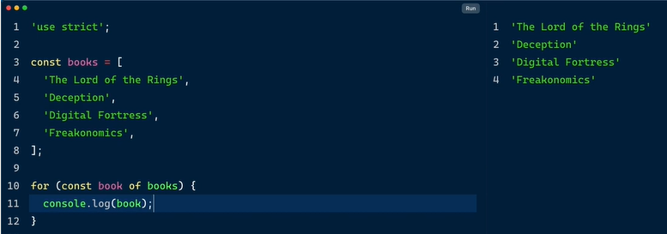

* So far we have used for of loop to iterate over an array

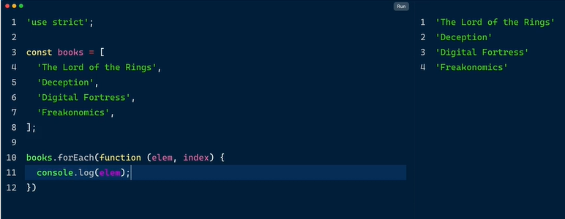

* For each method use chesam
* Call back function rasamu
* Elements index

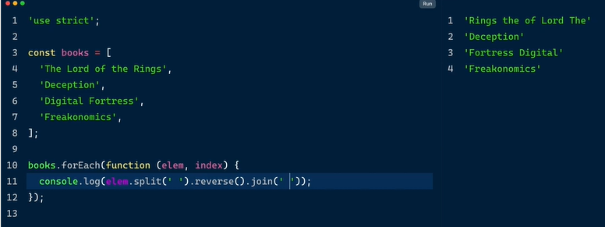

* Split by white space
* Reverse
* Join by white space
* We get flipped titles

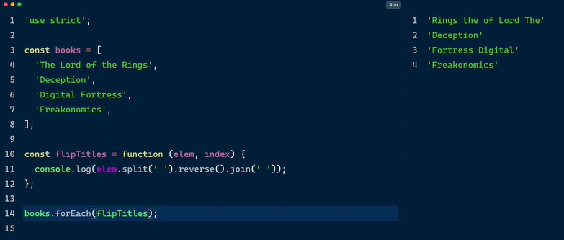

* Call back function can be created separately as a regular function
* flipTitles = variable name followed by function
* array.forEach method tho call chesam



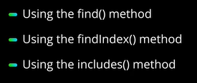

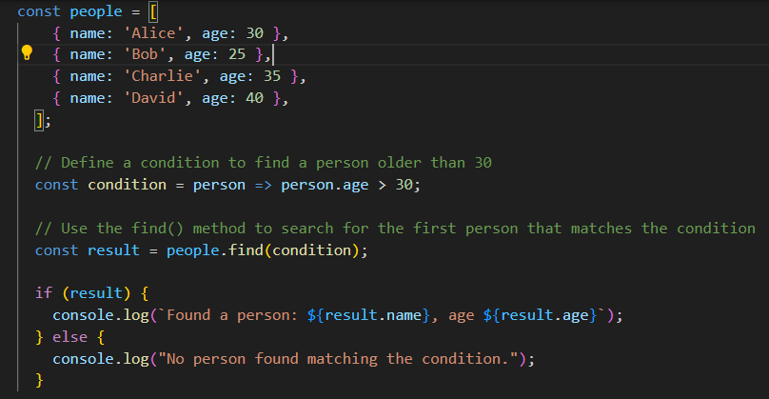

* find of method
* simple array of objects ni define chesamu
* defined a condition using arrow function
* find of method 1st match ayina search ni output chesthundi
* so 1st 35 kabatti adi outpiut lo chupinchi
* 35 kante 40 unte ade chupinchedi
* Only returns 1st match of elements , not all elements

Ways to find elements in an array

Find method

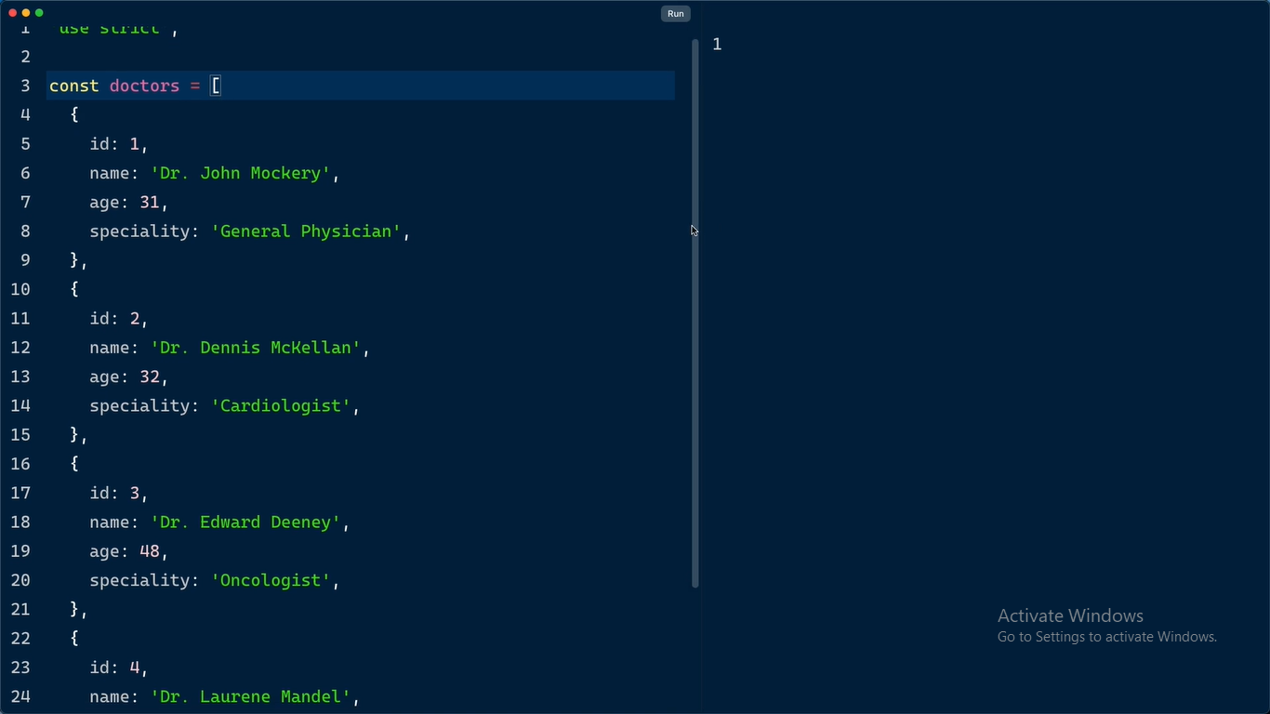

* Oka array of object lo doctor yokka id,name,age,speciality unnayi

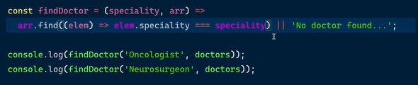

Daniki arrow function rasam

* find doctor = function
* 2 parameters specilaity,arr
* Arrow function uing arr.find
* Strict equality operator and
* Logical or operator for undefined
* Keys are called as elements in function
* Neurosurgeon ledu so undefined vasthundi
* Undefined kakaunda meaningful msg kavalante logical or operator use chesi msg print cheyachu
* Entire object print avthudi
* Motham object kakunda

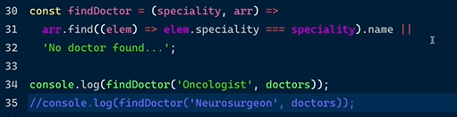

* Dot notation tho name access chesthe motham object kakunda name okate vasthundi
* Kinda neurosurgeon key ledu so comment it to get name property

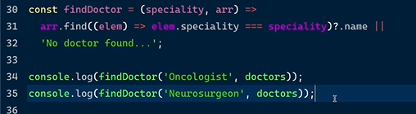

* Ala comment cheyakunda access cheyali ante
* Optional changing operator use cheyali
* Simply add a question mark

**Find index method**

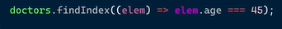

* Returns 1st match not all elements find index and findmethod
* 1st match kakunda anni matches chupinchali ante flitering metjod use cheyali

**Include method**

Result is true or false

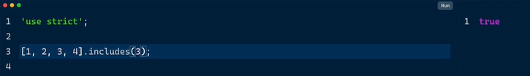

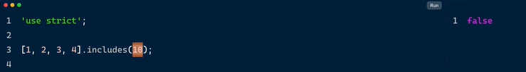



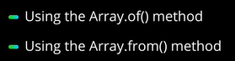

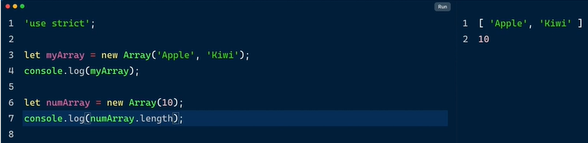

* Array constructor use chesi ela arrays ni create chestham
* Number array create chesinapudu length chusthe 10 empty lines vachayi

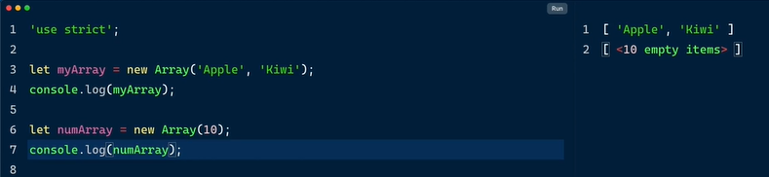

* E problem ni solve cheyadnaiki
* Arrow constructor kakunda array.of use chesi arrays ni create cheyachu

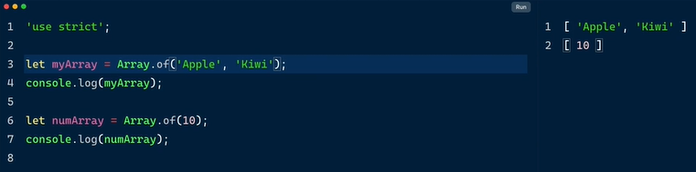

* E method ni replace chesthe length 10 and empty lines create avvavu
* Good replacement for array constructor function

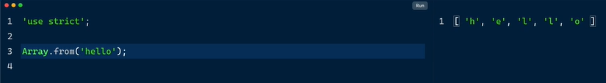

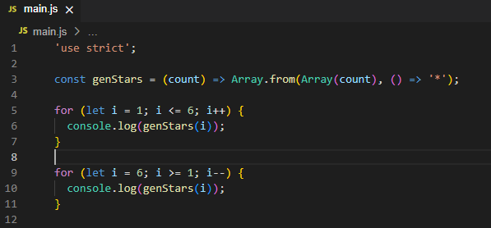

* Function name = genstars
* Parameter = count
* Array.from = method
* 1st iteration is ascending order , incrementation
* Intialiation I = 1
* Loop continues till <= 6
* 6 vachevaraku * ela 6 arrays create avthayi
* 2nd iteration is decrementation , descending order
* 6 nunchi start ayyi 1 varaku decrement avthundi

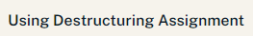



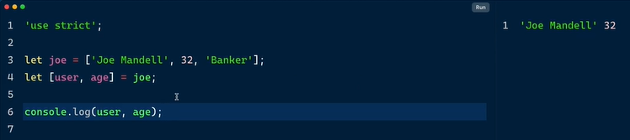

* Joe ane variable tho array create chesam
* User,age ani console chesthe index numbers 0 and 1 assign ayyayi
* Age thisesyi job ani pedithe banker rakunda malli age vachindhi 32 ani ante index number 1 acess chesthundi

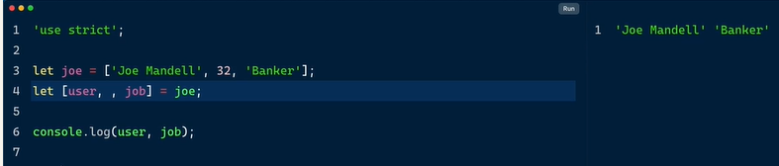

* Empty space vadilesi job ani pedithe correct ga access chesthundi
* Denni unpacking antaru

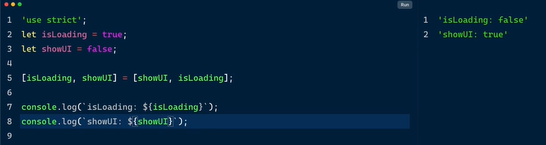

* Destructring assignment syntax ela use chesthe
* Values flip avthayi
* Intial ga manam pettina isLoading false avthadi
* showUI true avthadi
* isLoading, showUI = showUI, isLoadind [values are getting exchanged ]

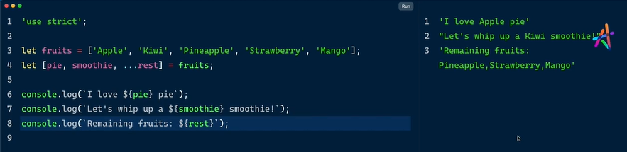

* fruits ane variable ki array assign chesam
* pie value apple
* smoothie value kiwi
* …rest parameter/operator remaining fruits



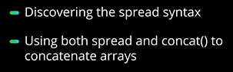

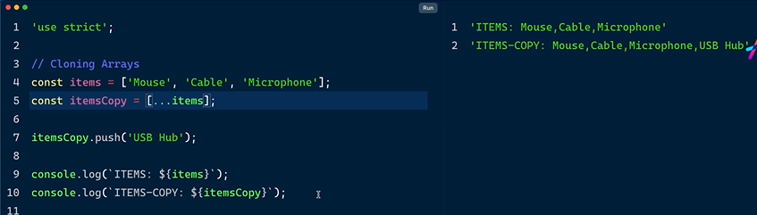

* …spread operator
* itemsCopy ane variable lo items copy avthayi
* .push ante kotha values add avthayi
* Print chesinapudu spread operator valla copy avthunnayi

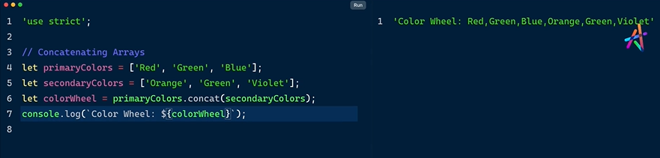

* This is the traditional way of concatenation
* Var.concat(var);

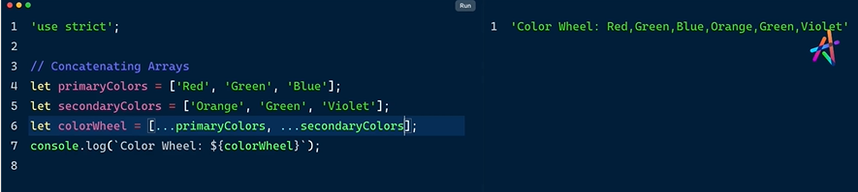

* Spread operator syntax use chesi ela cheyachu
* More than 2 arrays compare cheyachu e simple syntax tho



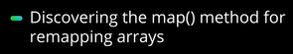

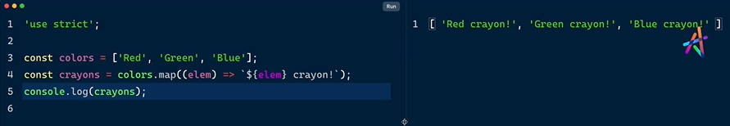

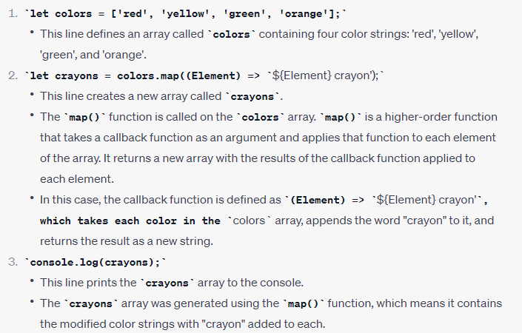

* Colors ane variable name tho array create chesam
* Crayons ane variable name colors tho map chesi every element meda iterate ayyi crayon ane word ani addchesthundi

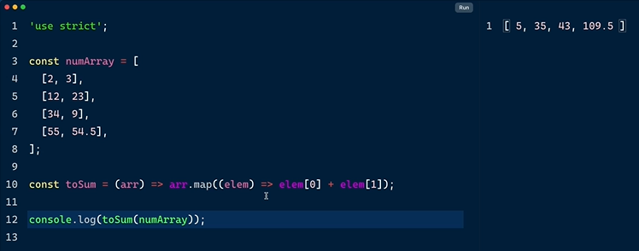

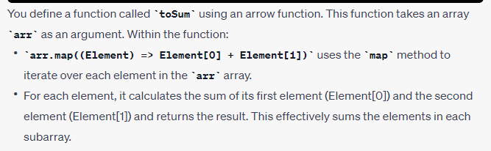

* numArray ane array lopala nested arrays create chesam
* function rasam array lopala unna numbers sum ayyi ravali ani
* toSum = function name
* arr = argument / parameter
* parameter.map
* prathi element lo unna 0th and 1st index ni sum cheyali
* 2+3 = 5

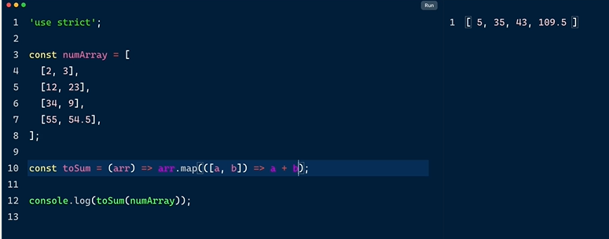

* Element thisesi
* Destructing means we did unpacking with a and b
* Makes it more readable



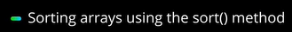

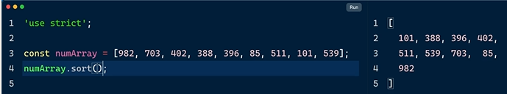

* Sort method direct ga run chesthe small to large numbers vasthayi

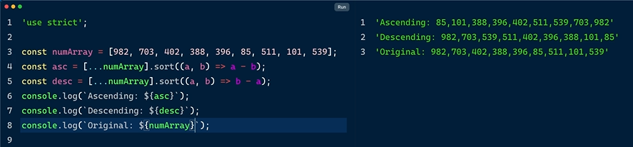

* Spread operator use chesam
* Arrow function rasam asc and desc order ki
* Asceding ki a-b 1st 2 elements
* Descending b-a
* Orginal

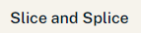

Methods

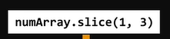

End index is not included

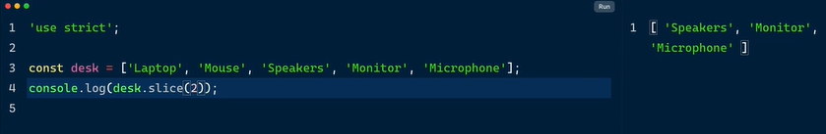

* Slice(2)
* Starts from index 2
* Slicing starts from 0 index

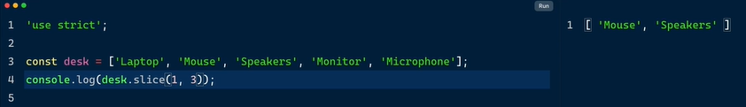

* Start index is included
* End index is not included

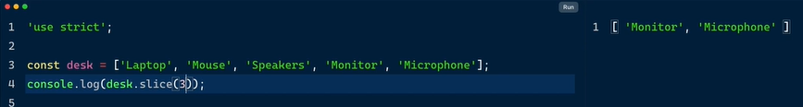

* Slicing 3rd index nunchi start avthadi
* And remaining count avthayi

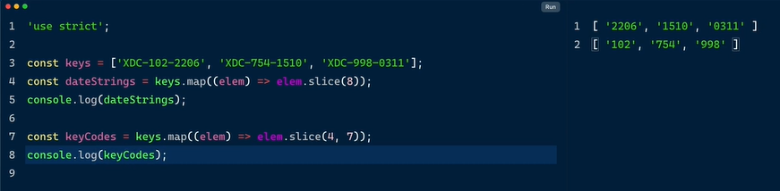

Splice method:replaces and inserts new elements

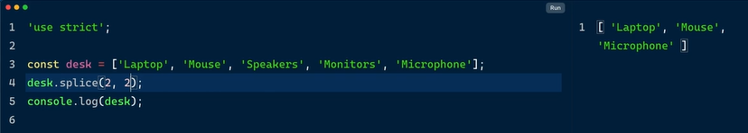

* Splice method lo 2,2 annau array lo unna 2nd element dani pakka element delete avthayi
* 2,1 = 2nd element delte avthundi
* Removing items
* Monitors delete avthundi endhuku ante spekars , speakers pakanna unnadi delte avvali annamu

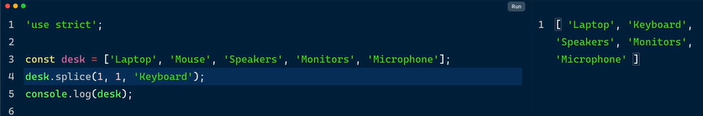

* Mouse element is replaced with keyboards

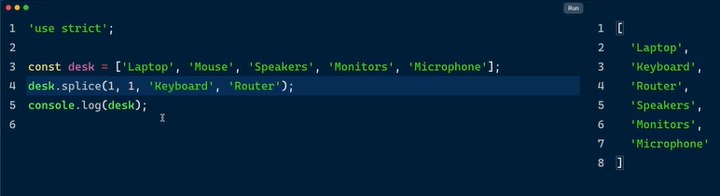

* Keyboard followed by router add chesam

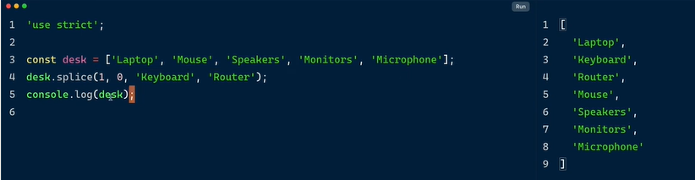

* Ela pedithe mouse delete avvadu
* 1st element pakkana 0th position lo keyboard , router add chesam
* Similar to push method

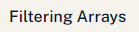



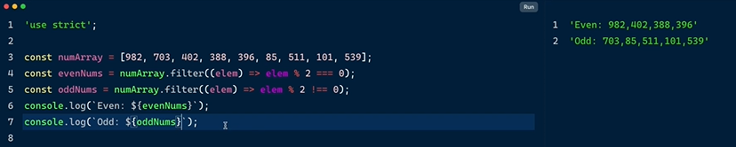

* Edi oka array
* Even numbers ni pick cheyali so modules 2 ===0
* Odd numbers modules 2 doesn’t not equal to 0

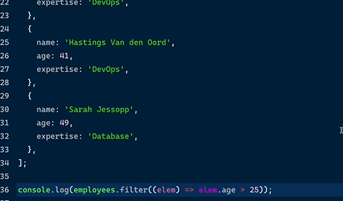

* Fliter age greater than 25 in an array of objects

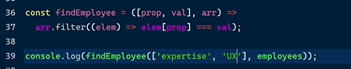

* findEmployee = function
* prop val = arguments
* arr = parameter
* arr ki fliter petti element property value ni check cheyamanam strict equality operator tho



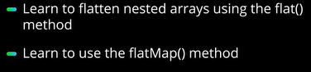

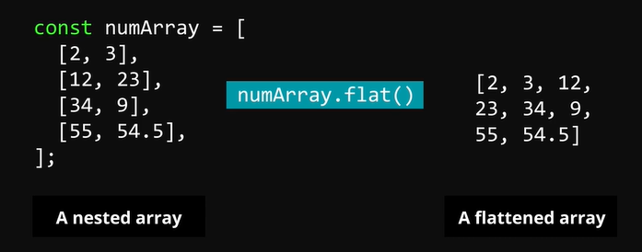

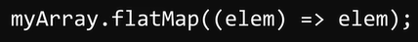

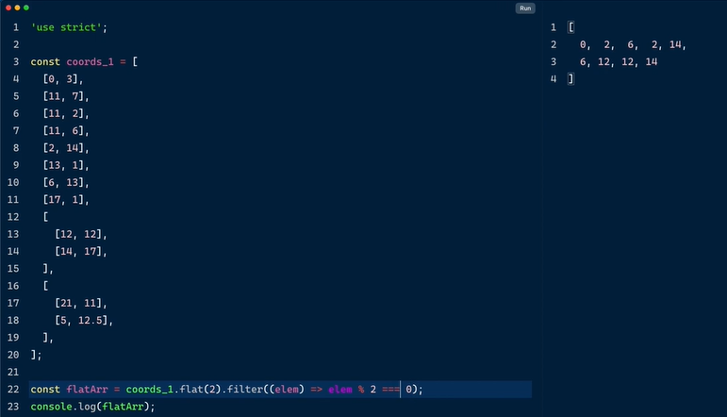

* Nested arrays , deeply nested arrays unnayi
* Flat() empty unte just display chesthundi
* Flat(2) ante unte specif number edi ayina isthe flatten ayyi chupisthundi
* Ekkada manam fliter method tho even number ni print chesam



Reduce method for sum

Accumulatoe, current value = parameters

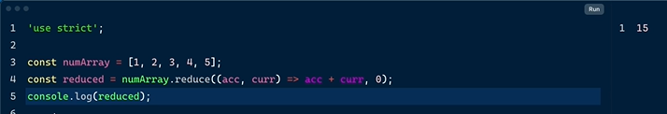

Reduce method for computing items and quantity, muntiples the quantity and cost

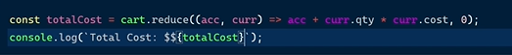

Array lopala objects

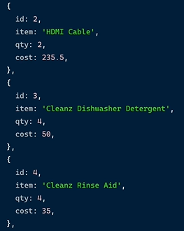

Total quantity of items purchased:

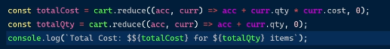

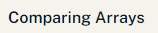

JSON STRINGIFY

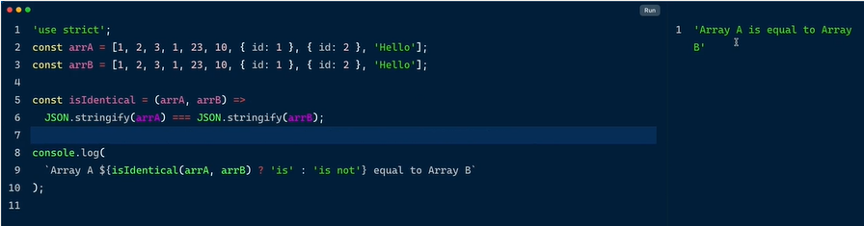

* Strict equality operator
* Ternary operator
* Conditions chusi equal ani return ayindi

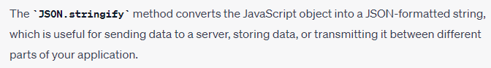

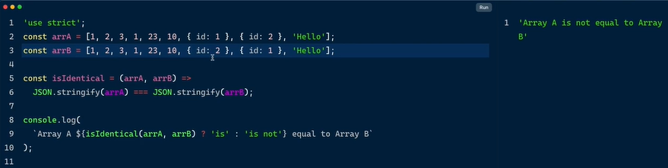

* Values change chesthe not equal ani vachindhi
* String laga convert ayyi vasthundi output

**MODULE – 2 WORKING WITH OBJECTS**

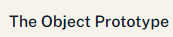



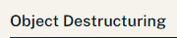

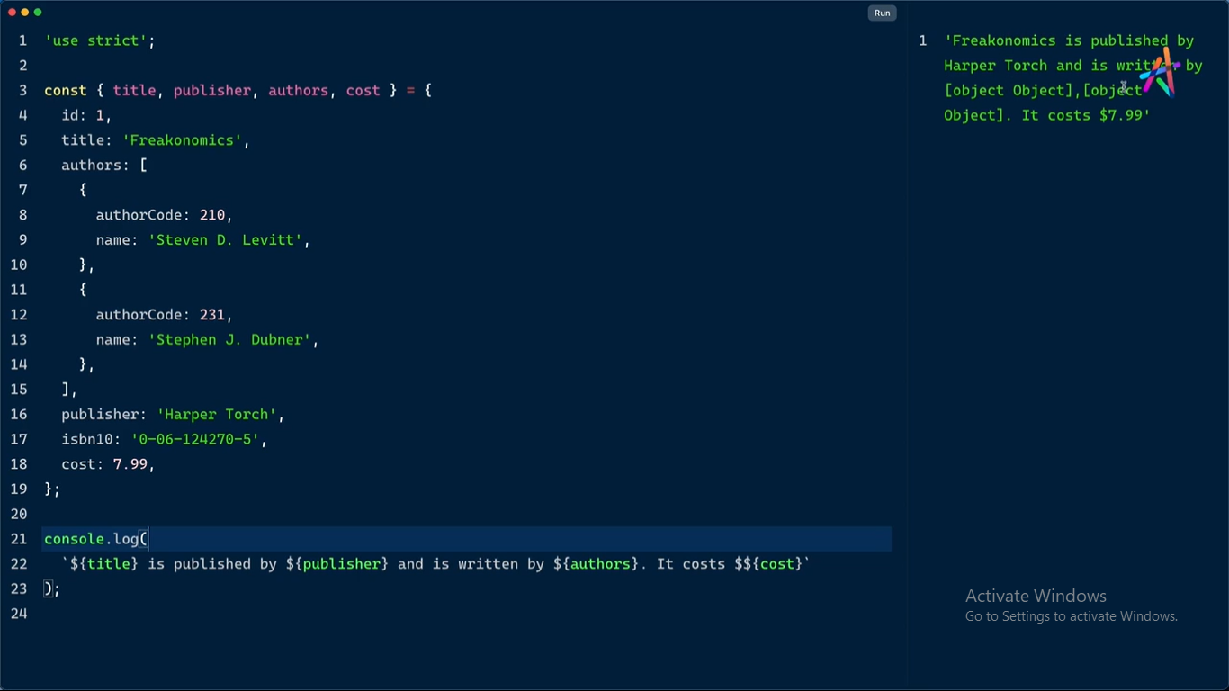

* Bracket notation
* Dot notation kakunda
* Const variable declaration lo title,publisher,authors,cost ani petti
* Multiline threads use chesi ela access cheyachu

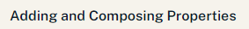

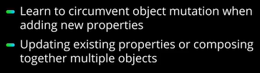

Spread operator ey function,conditions lo ela access cheyali ani chepadu



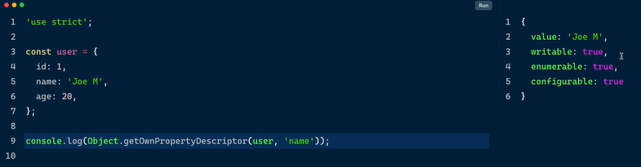

* Get own property descriptor user lo name ni access chesam
* Default values vasthayi
* Vatini change cheyachu
* Enumerable = false chesthe for loop chesinapud value anedi repeat avvakunda escape avthundi
* Writable= false chesthe effectively makes the property read-only; you can't change its value after it's been defined this way
* Configurable false preventing it from being deleted

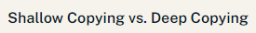

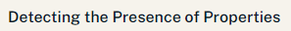

In operator = true

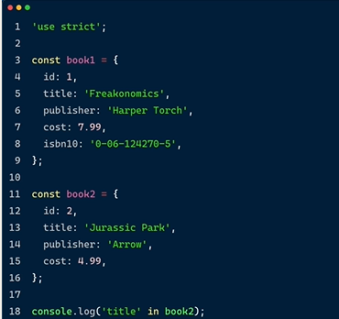

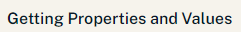

3 methods:

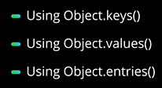

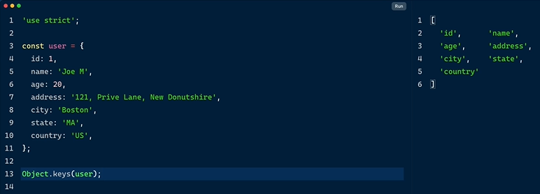

* Object lo keys ni ela access cheyali

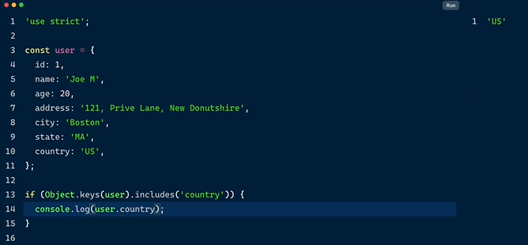

* If condition execute chesam
* Country ane key include ayithe
* Country ni print cheyi

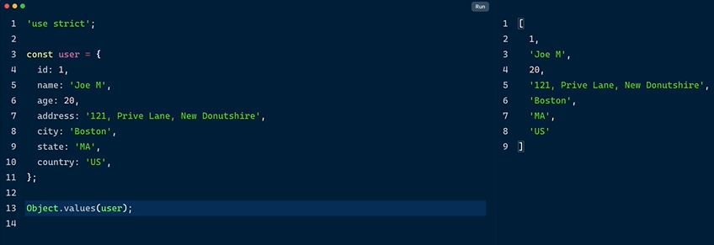

* Values ni matrame print chesthunnam

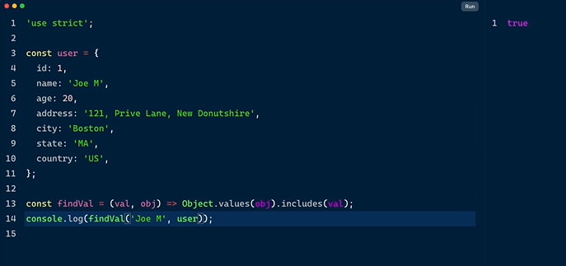

* findVal = function
* arguments = values, objects
* prints true if it contains user name with joeM

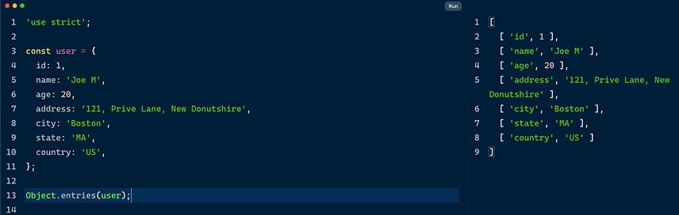

Entries method oka nested arrays laga convert chetshundi output lo

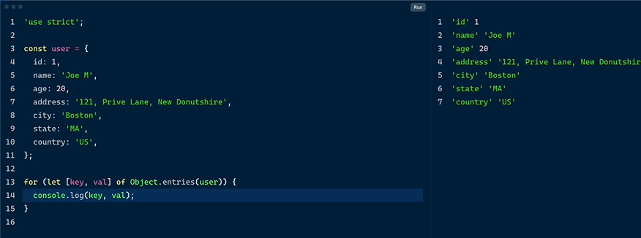

* for of loop
* key and value meda iterate avthunnam

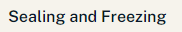

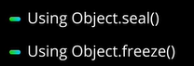

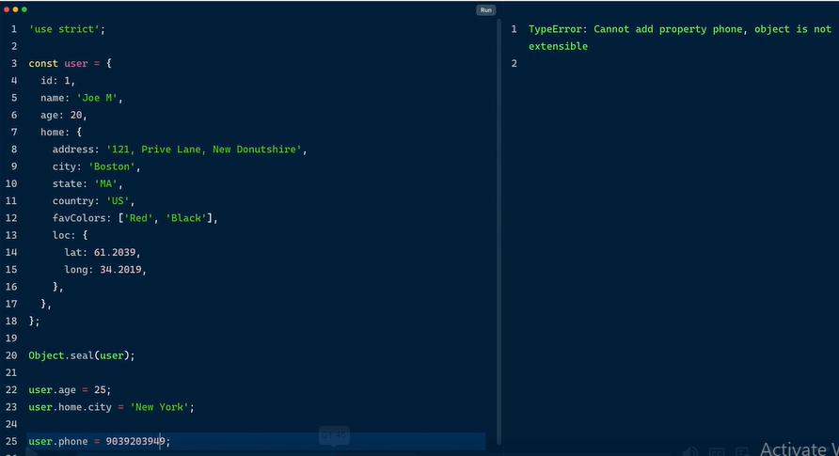

* when we seal the object we cant add top level property
* we get type error

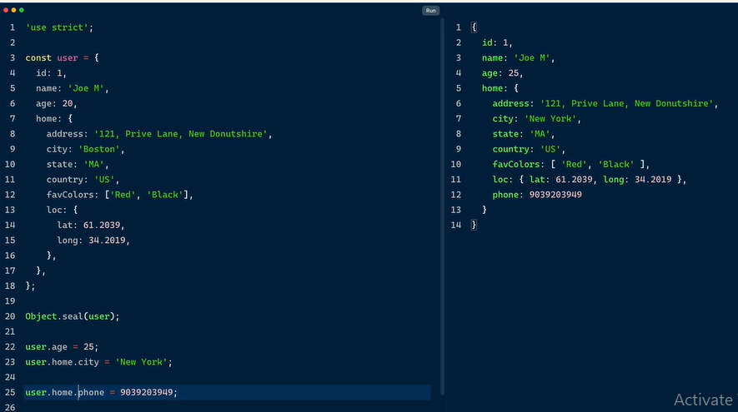

* Nested object ki add chesthe add ayindi even ater sealing

Object freeze: Completely freezes , no mutations, no mutable

**MODULE-3 ALL ABOUT STRINGS**



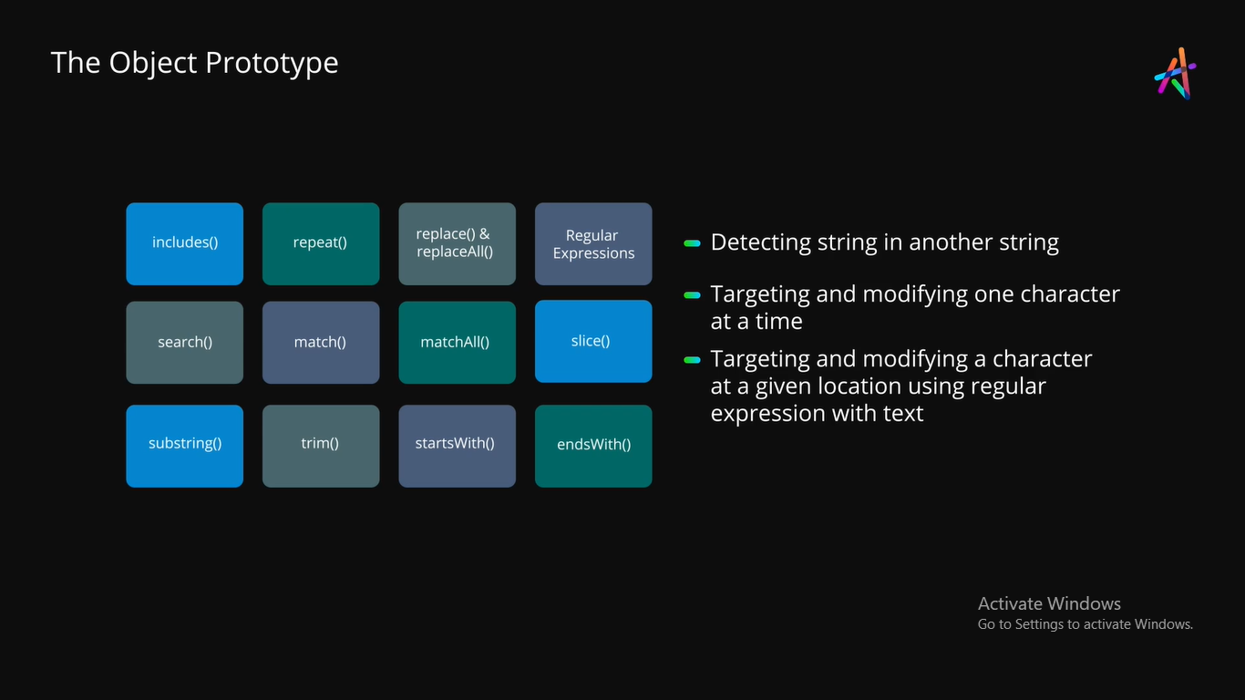



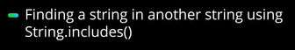



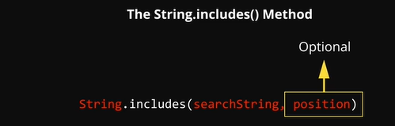





* 0 oka 10 times repeat avthundi

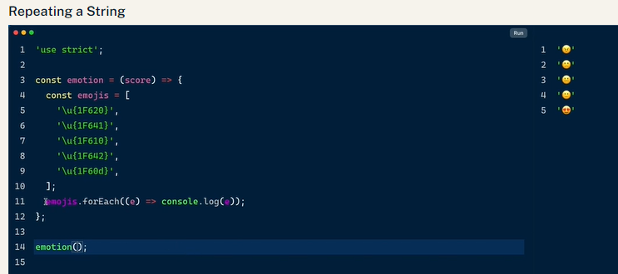

* Emotion = function name
* Score = parameter
* Unicode values given for emoji
* For each method for looping

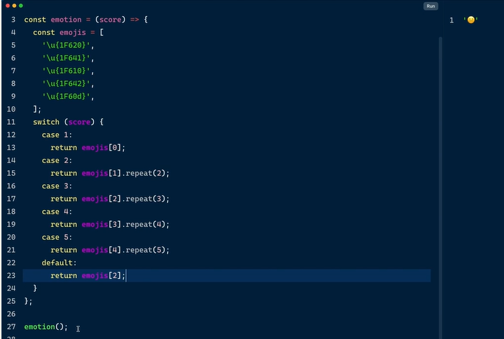

* Switch case condition
* Used return instead of continue/break
* Emption lopala value empty kabatti default chupisthundi output
* Repeat means ah emoji 5 times repeat ayyi vasthundi



* Score of one shows anger face

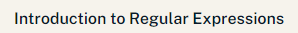

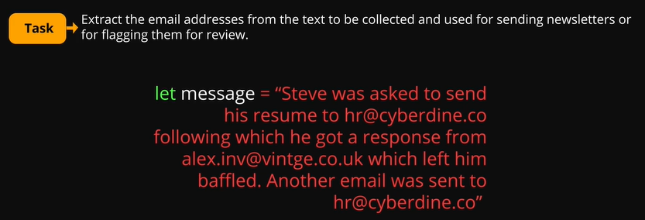

* I have to extract the mail id from the text below
* Regex pattern

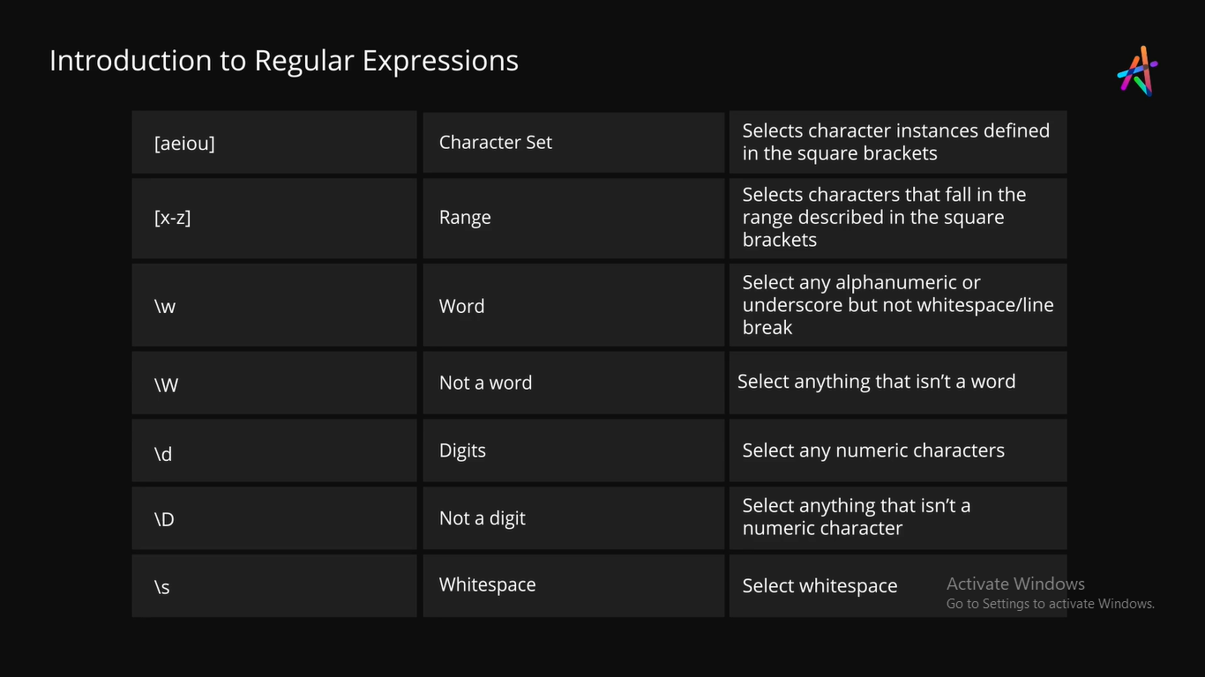

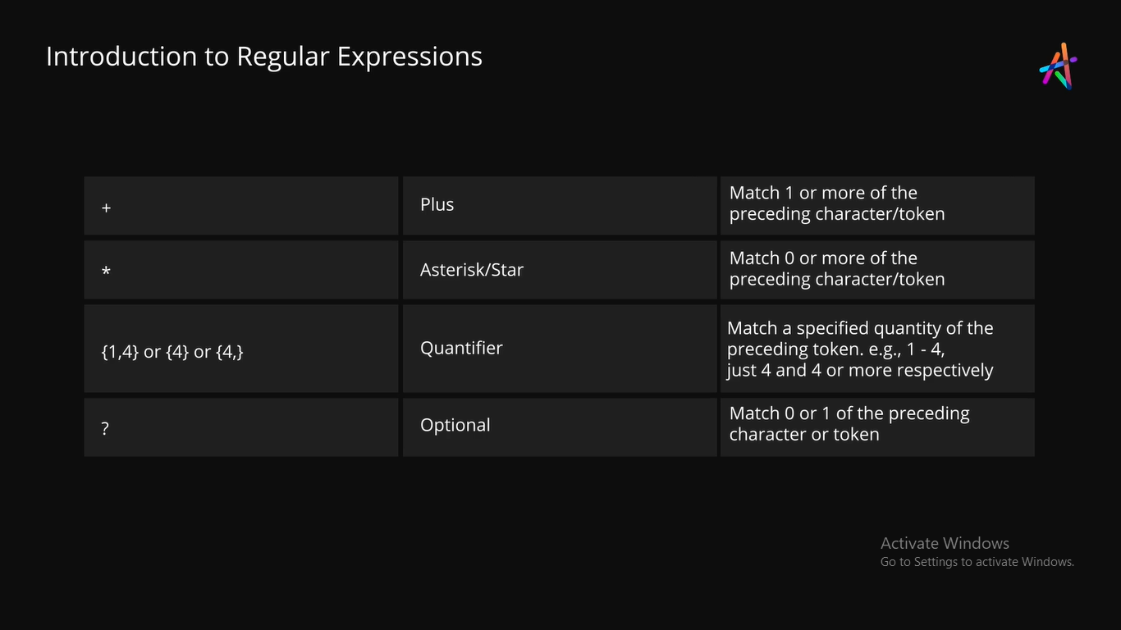

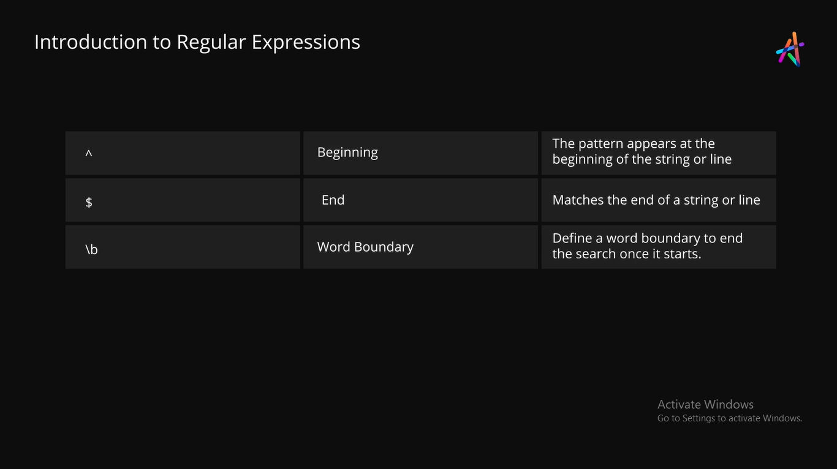

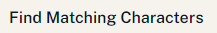

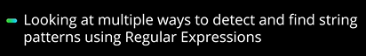

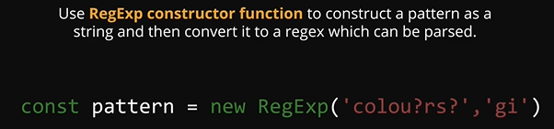

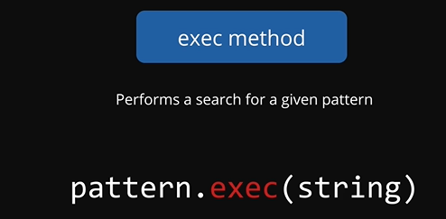

Execu search for given pattern

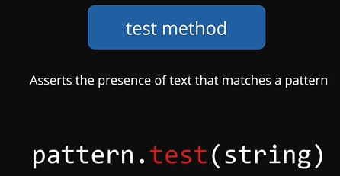

Test method

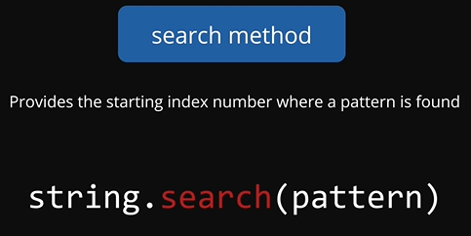

Search method

Shows index number at which the matched word begins

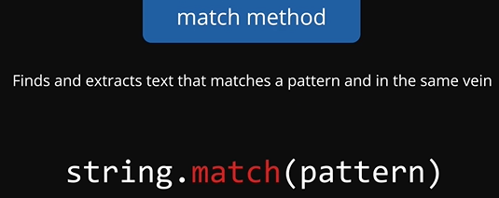

match method

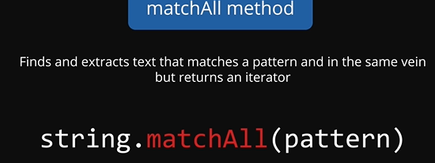

matchAll method

EXAMPLE:

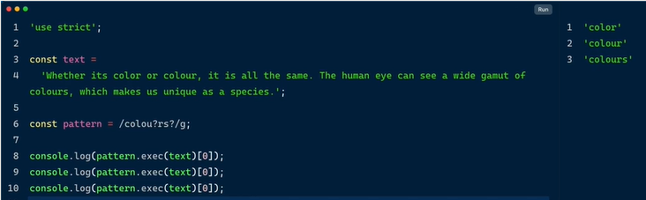

* Here I have some text
* Find the word colors or color based on both the American and British
* To find we 1st defined the pattern like this
* Exec ane method use chesthe matching unna vatini search chestham
* 1st possible match color 2nd time run chesthe text lo unna 2nd possible match vachindhi 3rd kuda anthe
* 4th chesthebtype error vachindhi nedhuku ante akkada ledu match color mana test cases 3 ey
* Ela type error rakudadu ante use while loop

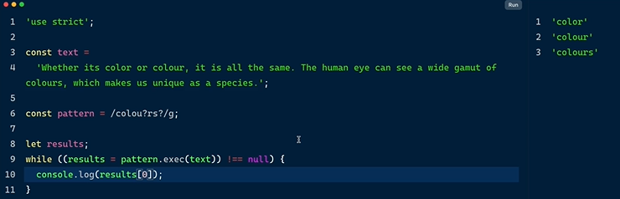

* Ekkada while loop use chesam
* !== null ayithe strict inequality
* Results print cheyali

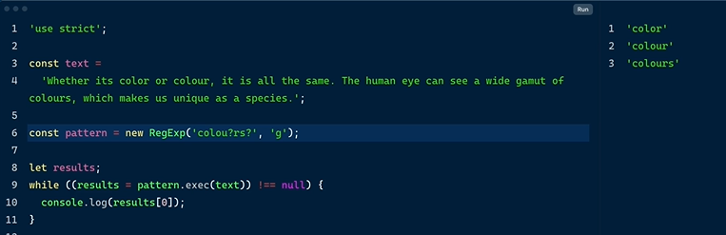

* 6th line regexp slashes lekunda ela kunda define cheyachu

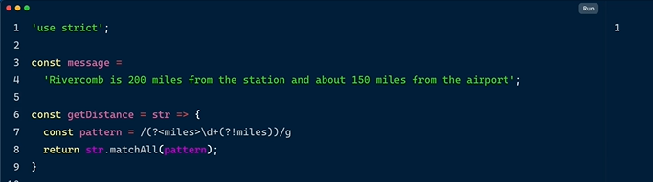

* getDistance = functionName
* str = one parameter
* return



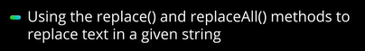

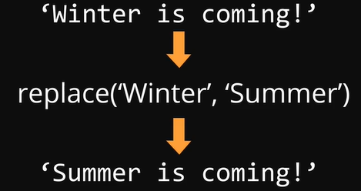



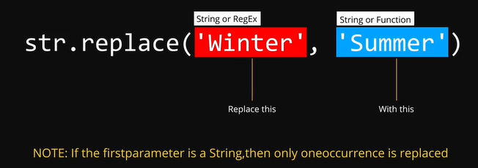

* replace method accepts 2 parameters
* 1st parameter is regex parameter word which is to be replaced
* 2nd parameter can be a string or function

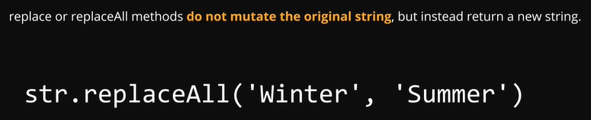

EXAMPLE:

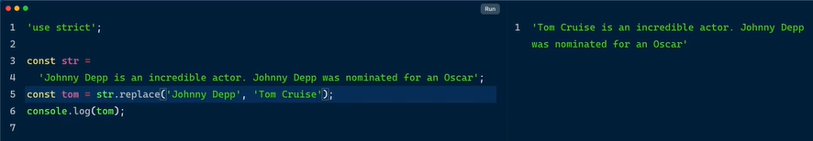

* Oka string undhi
* Replace method use chesi johny depp ane name ni tom cruise ga replace chesam
* Kani output only string starting lo change ayindi kani 2nd time same jogny deep an eundhi
* E problem ni solve cheyadaniki replace all method ni use chestham

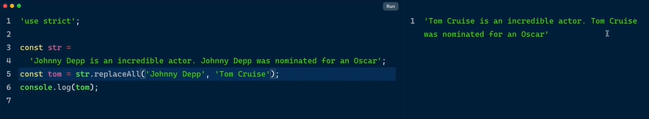

* Overall name has got changed

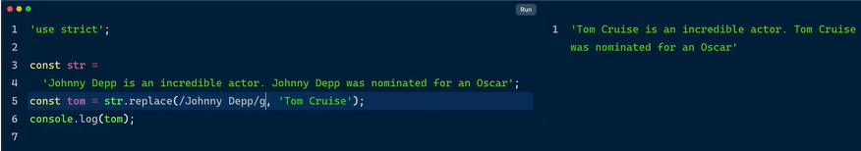

* Replaceall kakunda regular expression global tag kuda use chesi over all string lo unna text replace cheyachu

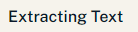



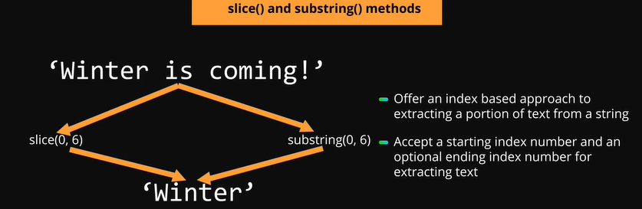

Starting index number is Positive number = starts from first of string

Starting index number is Negative number = starts from end of string

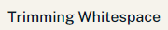

Ways to remove whitespace

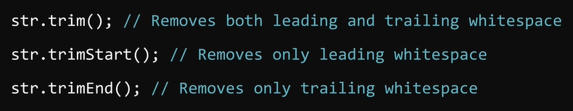

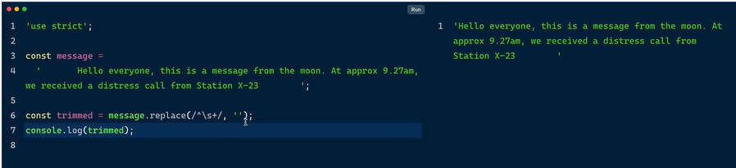

* Regging use chesi white space ni remove chesam
* //
* Trailing whitespace remove ayindi

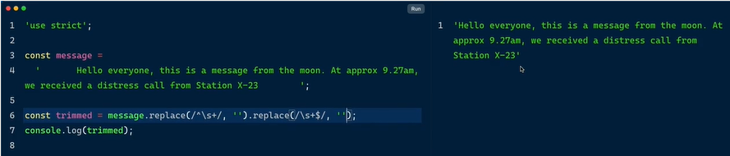

* Inko replace method use chesi ending whitespace ni remove chesamu

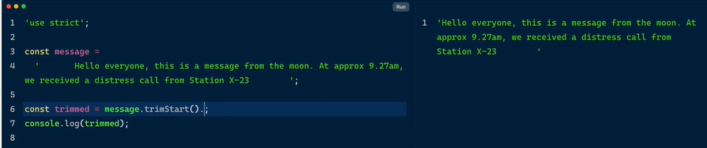

* Trim start removes the leading starting whitespace

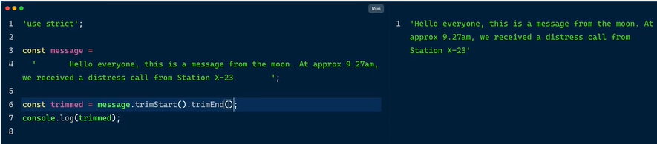

* Trim end removes the ending whitespace

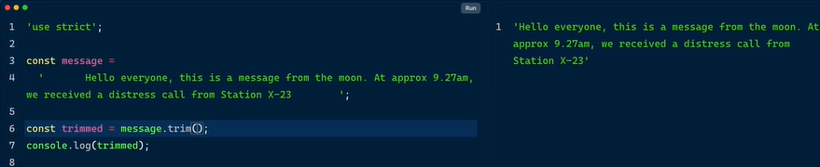

* Trim method removes both in one shot

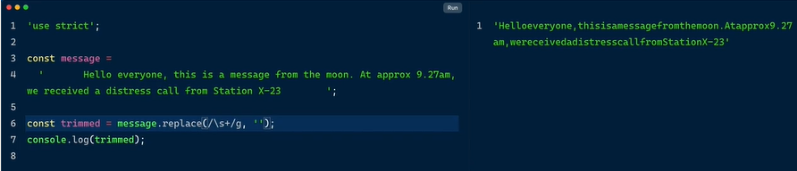

* This type of redgix pattern removes all whitespaces

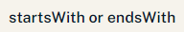



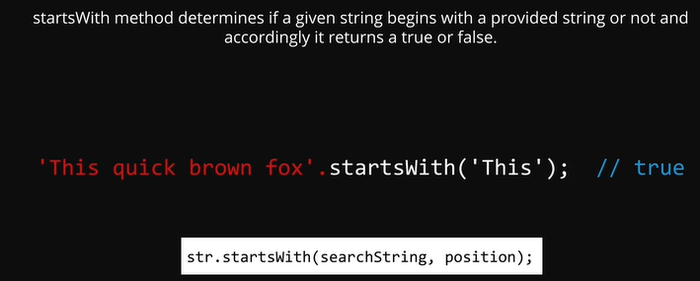

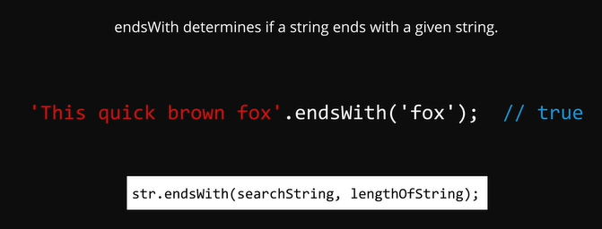

**MODULE – 4 DATE AND TIME**

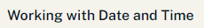

Banking for transactions

Amazon

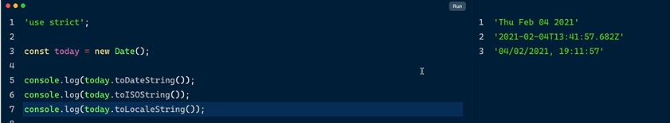

US TIMINGS

Timezones – world clock app

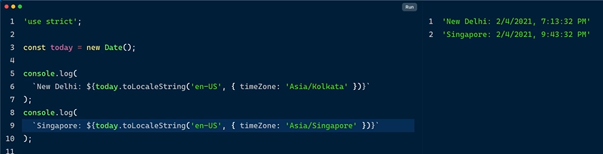

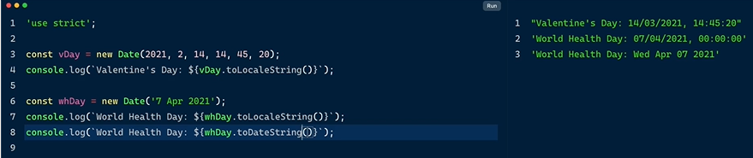

Ready to use static methods

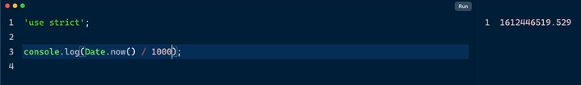

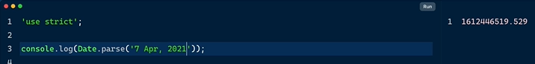

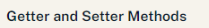

On date object instances



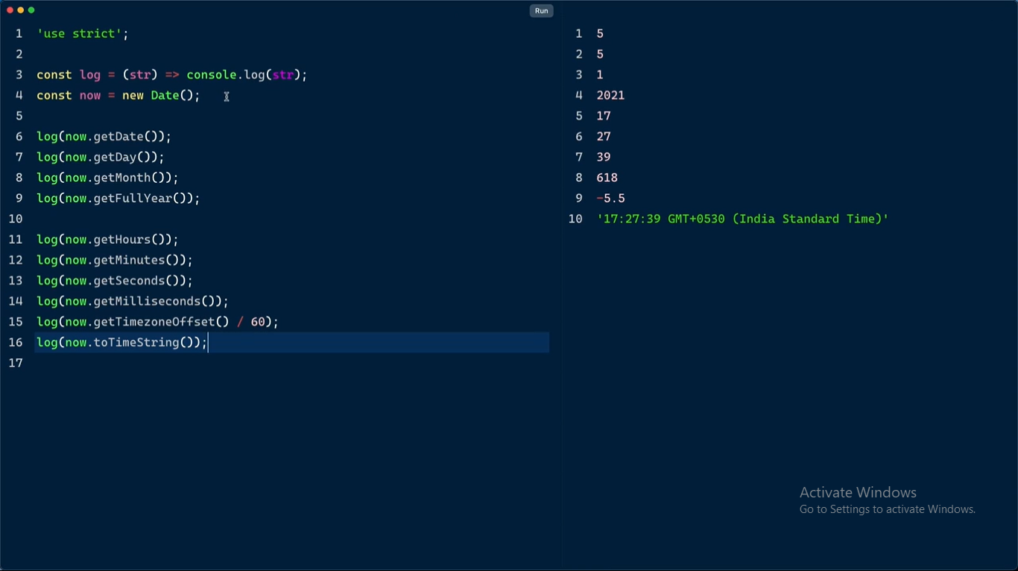

* Prathisari console.log rayakunda okesari short hand notation tho ala rasaru
* Line 3 refer
* These are all the getter methods
* Get day , month… methods antam

SETTER METHODS

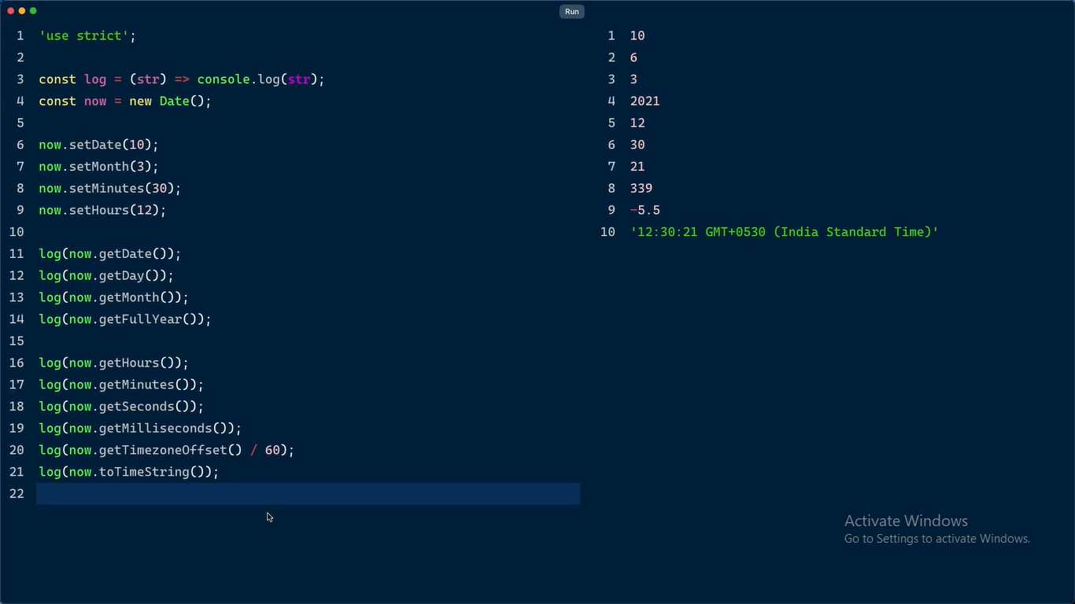

* Set chesthe em value set chesamo ah value update ayindi output lo

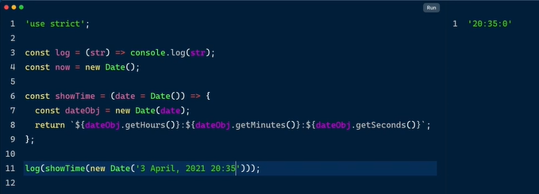

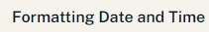

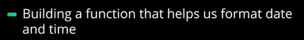

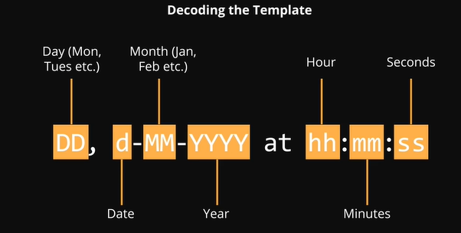

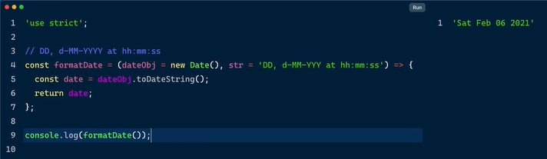

* Function name = format date
* This function accepts 2 parameters
* 1st parameter = dateObj
* 2nd parameter = str = format string
* dateObj must be a date object , in the absence of this argument it is set to a new instance of current date using default parameters
* str = format string which contains the keywords DD = days dd = date MM = months YY= years hh= hours mm = min ss= sec
* used toDateString(); = to get the date portion
* retur = to get output
* day month date is speartaed by space in output

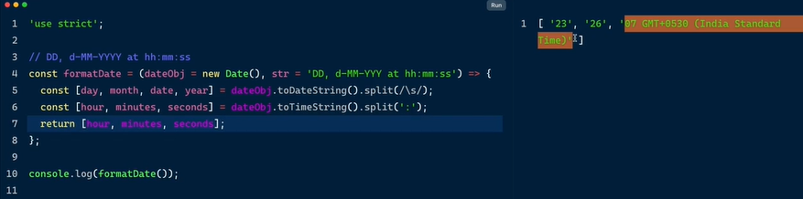

* toDateString() degara split separated by space used regular expression inside it
* toTimeString() degara split separated by colon
* we are returning h,m,s
* const [day, destructured 4 entities

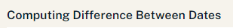

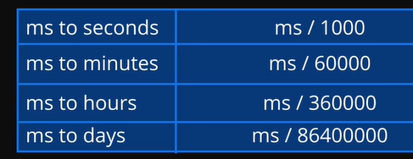

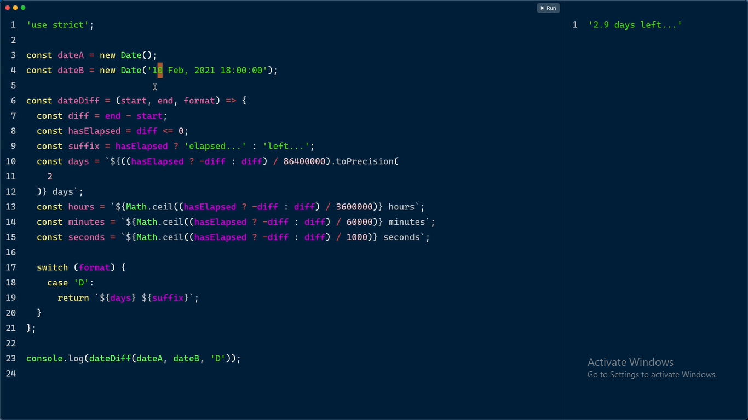

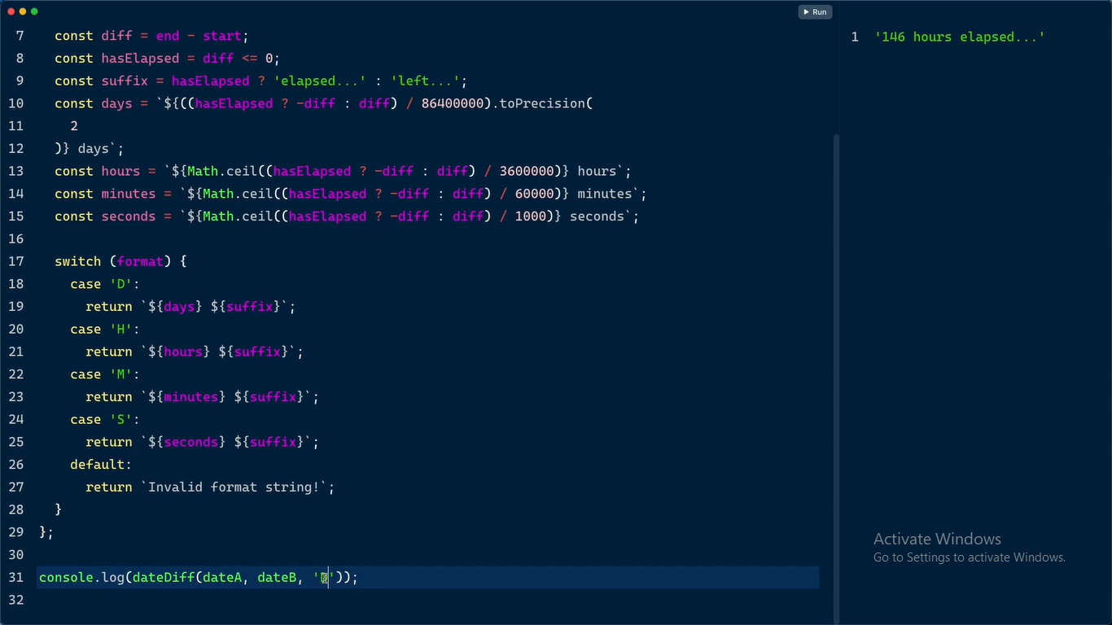

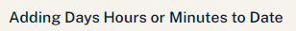

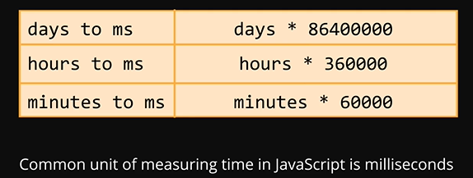

**WORKING WITH WEB PAGES PART – ONE**

DOM = DOCUMENT OBJECT MODEL



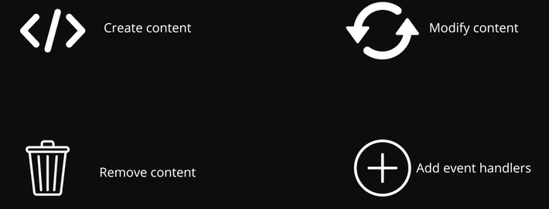



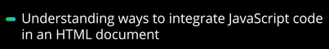

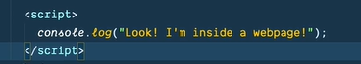

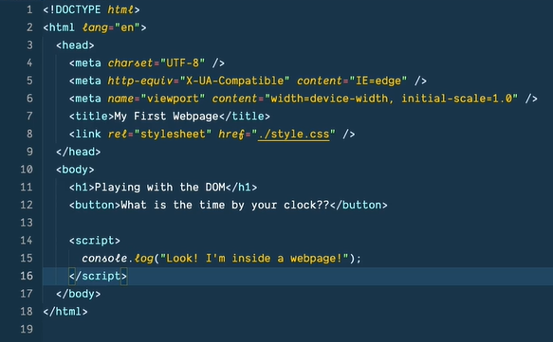

script tag inside html - inspect - check dev tools - console

body lo kuda pettachu head ey kadu

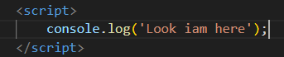

place right before closing body tag

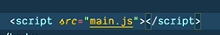

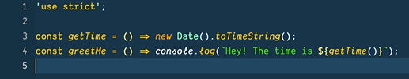



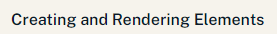

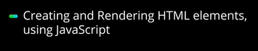

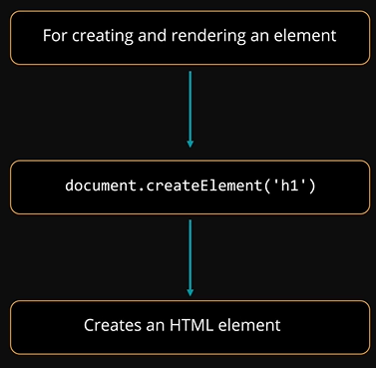

* To create elements in html
* Use method
* Document.createElement(in brackets create html tags )
* Attach to body and added title

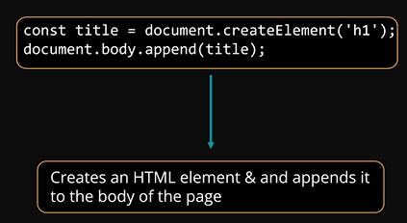

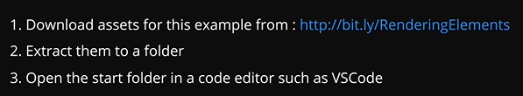

Start vs code open chesaka

Dependencies load avvadaniki npm I click chesa

Npm run dev